**Small Power Distance v Large Power Distance (PDI)**

**Knowledge**

**Definition**

Cultures and Organisations Software of the mind, G Hofstede, GJ Hofstede, M Minkov p 61

*“Power distance can therefore be defined as the extent to which the less powerful members of institutions and organizations within a country expect and accept that power is distributed unequally. Institutions are the basic elements of society, such as the family, the school, and the community; organizations are the places where people work.”*

**Hierarchy**

This is the degree of inequality between the people that is assumed to be a natural state of affairs. This attribute has been called Power Distance. In a society of large power distance, nobody thinks that people are all equal (or even should be) or should have the same prerogatives. Parents are not children, leaders are not followers, and kings are not citizens.

Many researchers have measured the degree of power distance in different countries. Such a measurement is always relative—one compares one country with other countries. It also depends on whom you consider, because power distance also differs within countries, becoming smaller as one climbs the social ladder. Within Europe, several studies have revealed that power distance in Northern and Western European cultures is smaller than in countries in Eastern and Southern Europe. The two areas are separated, roughly speaking and not coincidentally, by the former boundary of the Roman Empire. A similar line separates Anglo American from Latin American countries.

Hierarchy is related to wealth but not as strongly as individualism is. Researchers have found that as a country has become wealthier, power distance has decreased in many cases. Large power distance is easier to maintain in a situation of poverty and limited resources.

**Communication Style**

Large Power Distance

Large power distance culture emphasizes the unequal distribution of power in institutions and organizations in a hierarchy of privilege. A few people have a lot of power; the vast majority has little. Power is experienced as a personal attribute, something to be felt rather than enforced. A large power distance person will usually be quiet, soft-spoken, and polite, whether they are powerful individuals or not, but if they feel that you are being unfriendly or uncaring, they will be silent. A large power distance person will show their trust in you by asking for help and direction and will show their respect by remaining formal and lowering their eyes. When they make direct eye contact or do not display positive and animated nonverbal behaviour, you have probably hurt or insulted them and have lost their respect. They will not hesitate to talk but will be restrained and formal in their conversation, seeking to please you as best they can and accepting blame for any failure to please you. While they will internalize stress, they will give indirect signs of their stress in their interaction with you.

Small Power Distance

Small power distance culture values horizontal relationships where everyone is on a level playing field. Status symbols and privilege invite ridicule, and those who would set themselves above others are cut down to size. While a boss has power and authority, he or she must be careful to respect workers and share the benefits of that power whenever possible. Everyone is expected to have a voice in decision-making, and each person or group has rights and feels free to complain when those rights are violated. There is a strong sense of what is fair, and when workers sense they are being treated unfairly, they feel free to complain and negotiate to improve their situation.

**Awareness – Hierarchy Acceptance – Self Evaluation**

1. While reading the extracts below from Hofstede’s typical outward expressions on the two ends of the extremes of Low and High-Power distance societies highlight what you think is true for your cultural background/country where you live. If you think you lie in the middle of the two extremes highlight the gap in between.

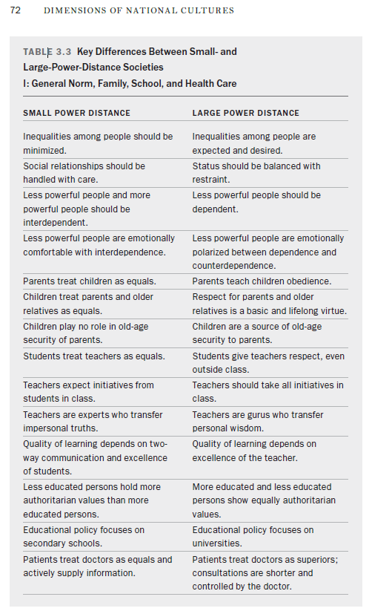

Cultures and Organisations Software of the mind, G Hofstede, GJ Hofstede, M Minkov: More Equal than others p72

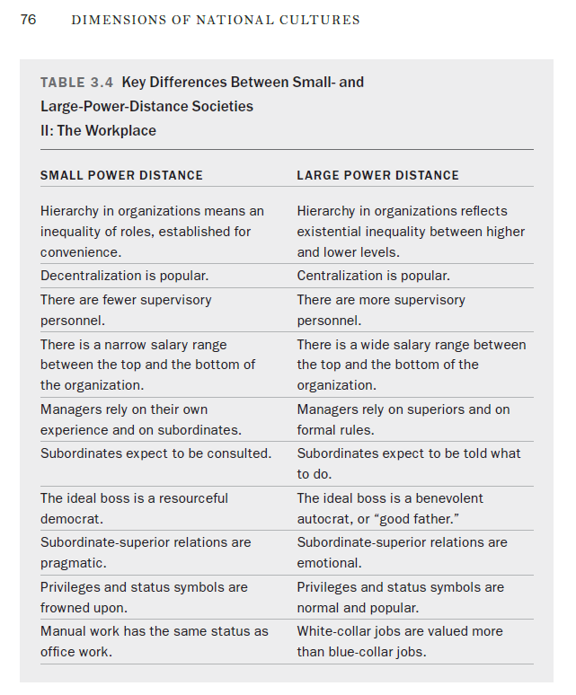

Cultures and Organisations Software of the mind, G Hofstede, GJ Hofstede, M Minkov: More Equal than others p76

1. Note down the number of statements you answered that correspond to small power distance, medium power distance and large power distance:
   1. Number of small power distance statements: ________________
   2. Number of medium power distance statements: ________________
   3. Number of large power distance: ________________
2. According to your cultural background and/or the country you live in look up the Power Index and note it down in the table. Use Hofstede’s globe on his website. <https://geerthofstede.com/hofstedes-globe/>

|  |  |
| --- | --- |
| **Country** | **Index** |
| Cultural Background: |  |
| Germany: |  |

1. Evaluate if the values you were taught correspond to Hofstede’s Power Distance Index for your cultural/national upbringing? Think about the differences and similarities and the reasons for this. Where would you put yourself on the Power Distance Index scale?